**Name :** omar khaled sayed ahmed

**Edu mail :** omar195605@feng.bu.edu.eg

**B.N :** 546

**Topic :** Big Data

**Why is Big Data Analytics So Important?**

Data is essential in today's business and technology world. Big Data technologies and initiatives are emerging to analyze this data and obtain information that can help in making strategic decisions. The concept was developed at the start of the 21st century and all of the tech giants are now using Big Data technologies. Big data refers to large and large data records that can be structured or unstructured. This large amount of data is produced daily by businesses and users. Big Data analysis examines large amounts of data to highlight ideas and patterns. The field of data analysis itself is vast.

## **Importance of Big Data Analytics**

Big data analysis is indeed a revolution in information technology. The use of data analysis by companies is improving year by year. Companies mainly focus on customers. As a result, the field is flourishing in B2C (Business to Consumer) applications. We divide the analysis into different types depending on the type of environment. We have three areas for big data analytics: Prescriptive Analytics, Predictive Analytics and Descriptive Analytics. This field offers immense potential. This blog discusses four perspectives to explain why big data analytics is so important today.

* Data Science Perspective
* Business Perspective
* Real-time Usability Perspective
* Job Market Perspective

**ScreenShots**

**Main Page**

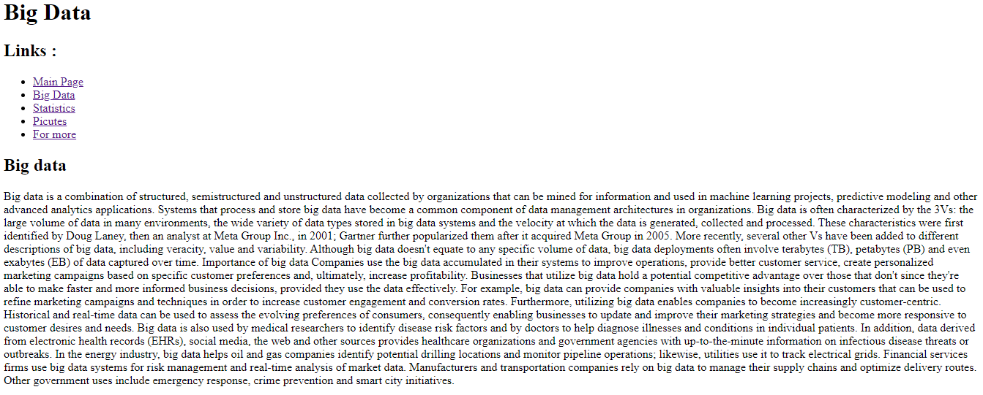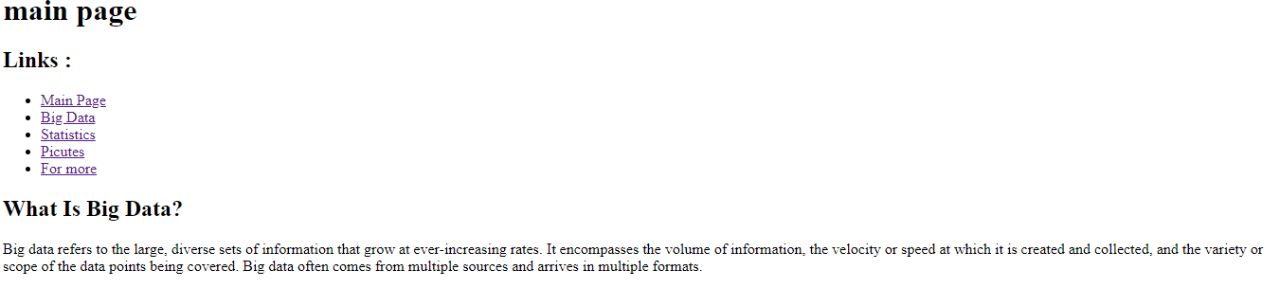

**Research Page**

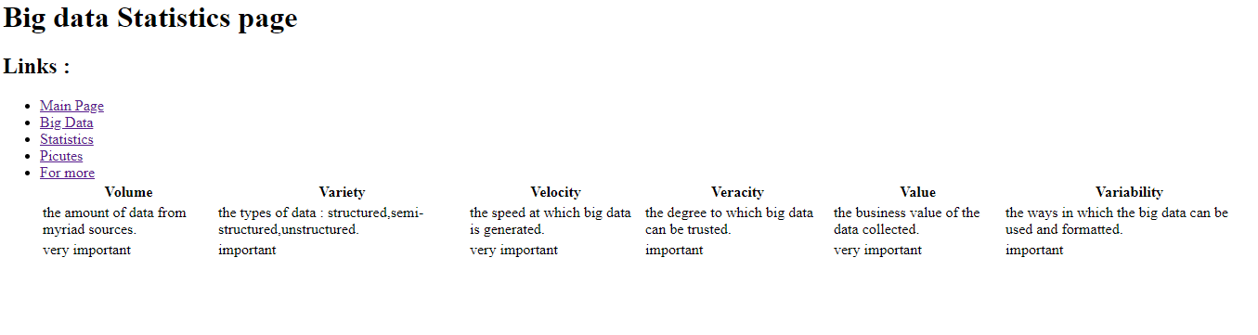**taples page**

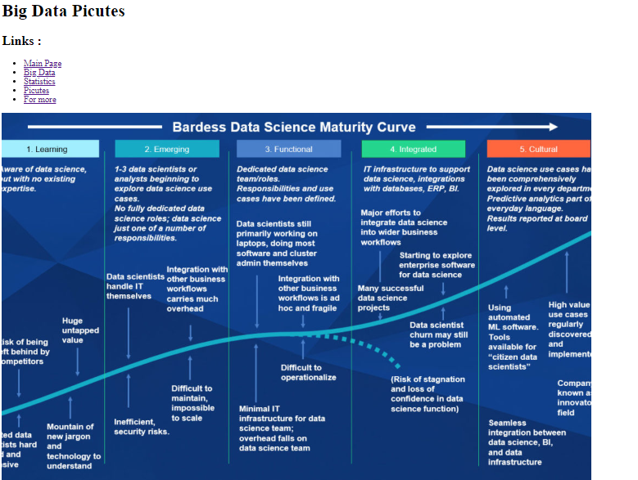**Pictures**

**Source code**

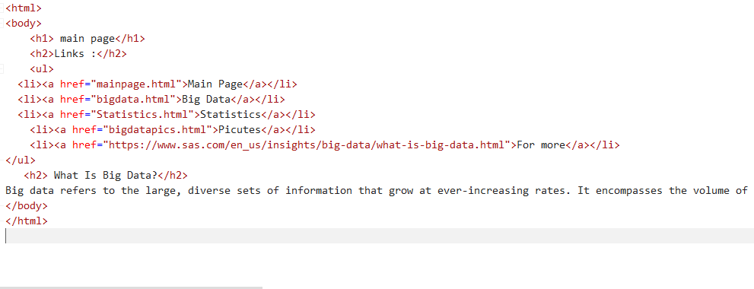**Main page**

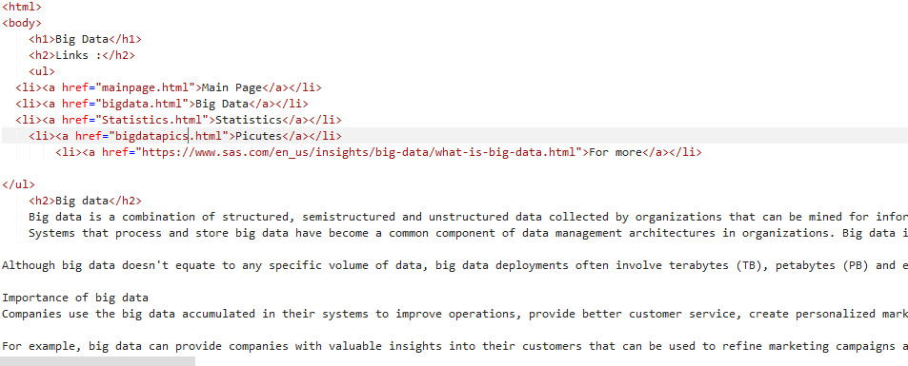**Research Page**

**Taple Page**

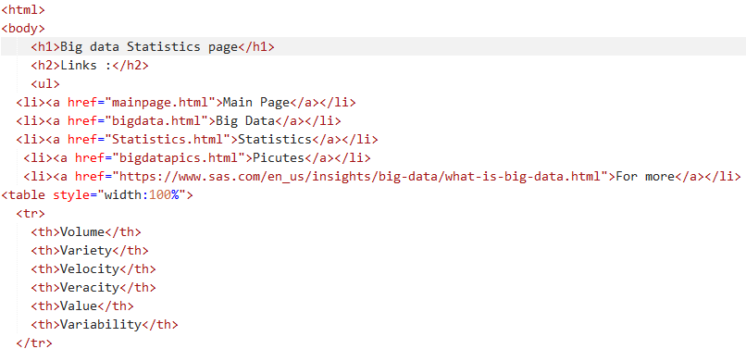

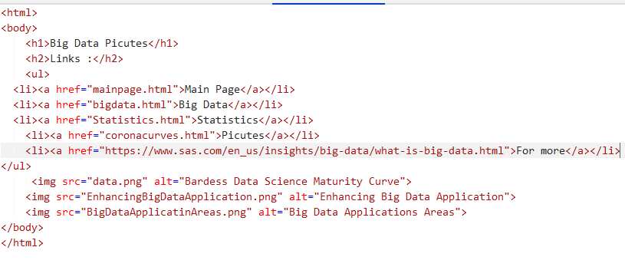**Pictures Page**